Day 5: Troubleshooting Network Services
Duration: 1 Hour | Theory: 15 Minutes | Practical: 45 Minutes
Topic: Troubleshooting DNS and DHCP Issues in a Simulated Network
Objective: Students will learn how to identify, troubleshoot, and resolve common DNS and DHCP problems using Cisco Packet Tracer and Windows Command Prompt.

1. Introduction to Network Troubleshooting
Network troubleshooting is the process of identifying and fixing problems that prevent devices from communicating properly over a network.
Real-time example:
Imagine an office has 20 computers. Suddenly:
- Some computers cannot access websites.
- Some computers are not receiving IP addresses automatically.
- Users can access a website using its IP address but not using its domain name.
A network administrator must identify the actual problem and resolve it.
Basic troubleshooting process:

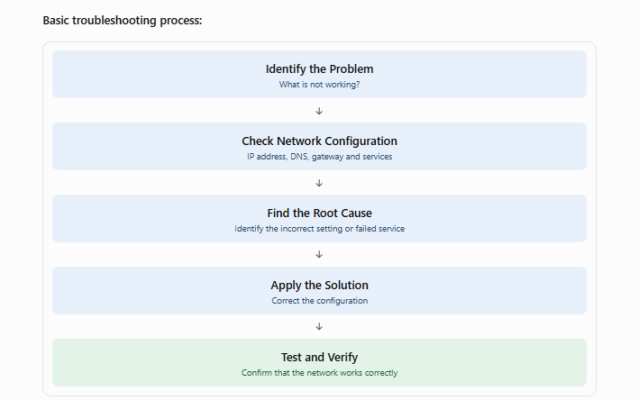

2. Common DNS Issues
DNS stands for Domain Name System. It converts domain names into IP addresses.
For example:
www.google.com → IP Address
When DNS does not work, users may be unable to access websites using domain names.

Common DNS problems and solutions
Problem | Possible reason | Solution
Website not opening by domain name | Incorrect DNS address | Configure the correct DNS server IP
Website opens using IP but not domain | DNS resolution failure | Check DNS service and A record
DNS server not responding | DNS service is OFF | Turn DNS service ON
Incorrect website IP returned | Wrong DNS record | Correct the A record
Domain name not resolving | Incorrect domain name | Verify the domain spelling
Old IP address returned | Cached DNS record | Clear DNS cache and retry

Important DNS troubleshooting commands
Windows CMD:
ipconfig /all
Displays IP address, DNS server, gateway and other network configuration.
nslookup google.com
Checks whether a domain name resolves to an IP address.
ipconfig /flushdns
Clears the local DNS cache.
ping 192.168.10.2
Checks connectivity to the DNS server.
Important: A successful ping does not always mean DNS is working. DNS resolution must be tested separately.

3. Common DHCP Issues
DHCP stands for Dynamic Host Configuration Protocol.
DHCP automatically provides network configuration to client devices, including:
- IP address
- Subnet mask
- Default gateway
- DNS server address

Common DHCP problems and solutions
Problem | Possible reason | Solution
Computer gets 169.254.x.x address | DHCP server not responding | Check DHCP server and network connectivity
Computer cannot obtain IP | DHCP service is OFF | Enable DHCP service
Duplicate IP address | Incorrect DHCP pool or static IP conflict | Correct the IP allocation range
Incorrect gateway | Wrong DHCP pool configuration | Set the correct default gateway
Incorrect DNS address | Wrong DNS option in DHCP pool | Update DNS server address
DHCP server not reachable | Network or VLAN issue | Check cables, switch ports and VLAN
Important: A Windows computer receiving an address beginning with 169.254 usually means it could not obtain an IPv4 address from a DHCP server. This is called APIPA.

Important DHCP troubleshooting commands
ipconfig /all
Displays the current DHCP and IP configuration.
ipconfig /release
Releases the current DHCP-assigned IPv4 address.
ipconfig /renew
Requests a new IP address from the DHCP server.
ipconfig /all
Run again to verify the new configuration.

PART A: PRACTICAL (45 MINUTES)

Practical: Troubleshoot DNS and DHCP Issues in Cisco Packet Tracer
Hands-on lab
Objective: Create a network with a DHCP and DNS server, intentionally introduce network configuration errors, identify the problems, and resolve them.

4. Network Topology
Required devices:
- 1 Server-PT
- 1 Switch 2960
- 3 PCs
- Copper Straight-Through cables

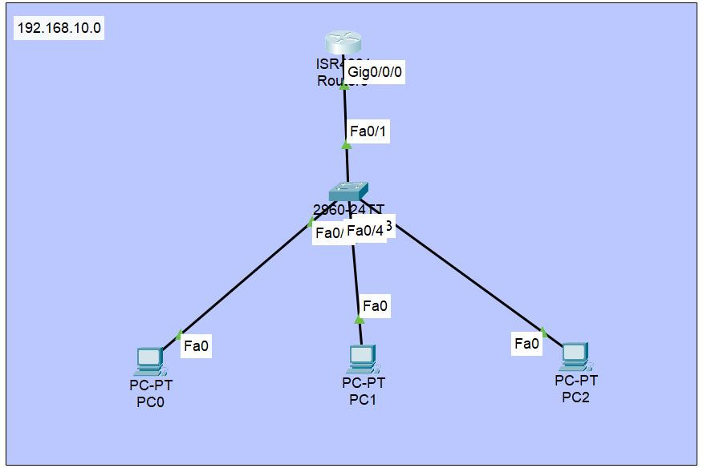IP Address Plan
Device | IP Address | Subnet Mask
Server | 192.168.10.2 | 255.255.255.0
PC0 | DHCP | Automatic
PC1 | DHCP | Automatic
PC2 | DHCP | Automatic
DNS Server IP: 192.168.10.2
Default Gateway: 192.168.10.1 (for this lab, no router is required for same-LAN testing; the gateway is only a configured option).

5. Step 1: Configure the Server
Click:
Server → Desktop → IP Configuration
Enter:
IP Address: 192.168.10.2
Subnet Mask: 255.255.255.0
Default Gateway: 192.168.10.1
DNS Server: 192.168.10.2

6. Step 2: Configure DHCP Service
Click:
Server → Services → DHCP
Turn DHCP Service ON.
Create the following pool:
Field | Value
Pool Name | STUDENT_LAB
Default Gateway | 192.168.10.1
DNS Server | 192.168.10.2
Start IP Address | 192.168.10.100
Subnet Mask | 255.255.255.0
Maximum Users | 50
Click Add or Save, depending on the Packet Tracer version.

7. Step 3: Configure DNS Service
Click:
Server → Services → DNS
- Turn DNS Service ON.
- Add the following DNS record.
Field | Value
Name | www.studentlab.com
Type | A Record
Address | 192.168.10.2
Click Add.
Also enable the HTTP service on the same server:
Server → Services → HTTP → ON
This allows students to test the domain name using the web browser.

8. Step 4: Configure PCs Using DHCP
For each PC:
- Click PC0.
- Open Desktop.
- Select IP Configuration.
- Click DHCP.
Repeat for PC1 and PC2.
Expected configuration:
PC | Expected IP
PC0 | 192.168.10.100
PC1 | 192.168.10.101
PC2 | 192.168.10.102
The actual addresses may differ depending on the order in which devices request leases.

9. Step 5: Test the Network
On PC0, open Command Prompt.
Check IP configuration:
ipconfig
Ping the server:
ping 192.168.10.2
Test domain resolution:
ping www.studentlab.com
Open PC0 → Desktop → Web Browser.
Enter:
http://www.studentlab.com
If everything is configured correctly, the server's web page should open.

PART B: TROUBLESHOOTING CHALLENGES
Now students must intentionally create problems and solve them.

Challenge 1: DNS Server Not Working
Problem: The user can ping the server using its IP address but cannot access the website using its domain name.
Trainer creates the issue:
- Open Server → Services → DNS.
- Turn DNS Service OFF.
Student task:
- Test ping 192.168.10.2.
- Test ping www.studentlab.com.
- Identify why the domain name is not resolving.
- Enable DNS Service.
- Test the domain again.
Expected solution: DNS Service must be ON and the correct A record must exist.

Challenge 2: Incorrect DNS Record
Problem: The website domain resolves to the wrong IP address.
Trainer creates the issue:
Change the DNS A record:
www.studentlab.com → 192.168.10.50
Actual server IP:
192.168.10.2
Student task:
- Test the domain name.
- Identify the incorrect IP address.
- Correct the DNS record.
- Test again.
Expected solution:
www.studentlab.com → 192.168.10.2

Challenge 3: DHCP Service Disabled
Problem: New computers are not receiving IP addresses automatically.
Trainer creates the issue:
- Open Server → Services → DHCP.
- Turn DHCP Service OFF.
Student task:
- Open PC0 → Desktop → IP Configuration.
- Select DHCP.
- Observe the result.
- Identify why the PC cannot obtain an IP address.
- Enable DHCP Service.
- Request an IP address again.
Expected solution: Enable DHCP Service and renew the client configuration.

Challenge 4: Incorrect DHCP DNS Configuration
Problem: PCs receive IP addresses successfully, but domain names do not resolve.
Trainer creates the issue:
In the DHCP pool, change the DNS Server value to:
192.168.10.50
Actual DNS server:
192.168.10.2
Student task:
- Check the PC's DNS address.
- Identify the incorrect DNS configuration.
- Correct the DHCP pool.
- Renew the PC's DHCP configuration.
- Test the domain name again.
Expected solution: Configure the correct DNS server IP in the DHCP pool and renew the client lease.

Challenge 5: Incorrect DHCP Gateway
Problem: A PC receives an IP address but has an incorrect default gateway.
Trainer creates the issue:
Change the DHCP pool gateway to:
192.168.10.254
Correct gateway:
192.168.10.1
Student task:
- Check the default gateway using ipconfig.
- Identify the incorrect gateway.
- Correct the DHCP pool.
- Renew the client configuration.
- Verify the new gateway.
Expected solution: Update the default gateway in the DHCP pool.
Trainer's note
For challenges 4 and 5, students should release and renew their DHCP configuration after correcting the pool. Existing leases may need to be renewed before the new DHCP options appear.
ipconfig /release
ipconfig /renew

PART C: STUDENT TASK – TROUBLESHOOTING REPORT

10. Document Solutions for Common DNS and DHCP Issues
Each student must prepare a troubleshooting report based on the practical exercises.
Use this format:
No. | Problem | Cause | Solution | Verification
1 | DNS not resolving | DNS service OFF | Enable DNS | Domain resolves
2 | Wrong IP returned | Incorrect A record | Correct A record | Correct IP displayed
3 | DHCP not assigning IP | DHCP service OFF | Enable DHCP | Client receives IP
4 | Wrong DNS on client | Incorrect DHCP DNS option | Correct DNS IP | Domain resolves
5 | Wrong gateway | Incorrect DHCP gateway | Correct gateway | Gateway verified

Student Assignment Questions
- What is network troubleshooting?
- What is the difference between DNS and DHCP?
- What happens when the DNS server is not responding?
- Why does a computer receive a 169.254.x.x address?
- What is the purpose of ipconfig /release?
- What is the purpose of ipconfig /renew?
- How can you identify an incorrect DNS server address?
- What happens if the DHCP gateway is incorrect?
- Why can a user access a server using an IP address but not its domain name?
- Explain the troubleshooting process with one real-time example.

Submission Requirements
- Packet Tracer network topology screenshot.
- DHCP configuration screenshot.
- DNS configuration screenshot.
- Successful IP configuration screenshot.
- Screenshots of troubleshooting before and after fixing issues.
- Completed DNS and DHCP troubleshooting report.
- Save Packet Tracer file as Day5_DNS_DHCP_Troubleshooting.pkt.

11. Quick Revision
Command / Concept | Purpose
ipconfig /all | View complete network configuration
ipconfig /release | Release DHCP IP address
ipconfig /renew | Request a new DHCP IP address
ipconfig /flushdns | Clear DNS cache
nslookup domain.com | Test DNS resolution
ping IP | Test network connectivity
DNS | Converts domain names into IP addresses
DHCP | Automatically assigns IP configuration
APIPA | Automatic IPv4 address when DHCP assignment fails
End-of-day discussion:
Ask students:
"If you are working as a network administrator and a user says that the internet is not working, what will you check first: IP address, DNS, DHCP, or gateway? Explain your troubleshooting steps."
This helps students think like real network support engineers instead of simply memorizing commands.

